

**Mawlana Bhashani Science and Technology University**

**Lab-Report**

Report No:01

Course code: ICT-3110

Course title: Operating System Lab

Date of Performance:

Date of Submission:

**Submitted by Submitted To**

Nazrul Islam

Assistant Professor

Dept. of ICT

MBSTU.

Name: Azharul Islam

ID:IT-18052

3rd year 1stsemester

Session: 2017-2018

Dept. of ICT

MBSTU.

***Experiment No:1***

***Experiment Name:*** How to Install Linux Operating System.

***Theory:***

An Operating System (OS) is an interface between a computer user and computer hardware. An operating system is a software which performs all the basic tasks like file management, memory management, process management, handling input and output, and controlling peripheral devices such as disk drives and printers.

***Working Process:***

We can install Linux through various procedure. Such as

**1.** Using USB stick.

**2.** Using CD ROM.

**3.** Using Virtual Machine

Now we will see how to install linux using Virtual machine.

**Step -1**: First of all,we need to Download Virtual box.

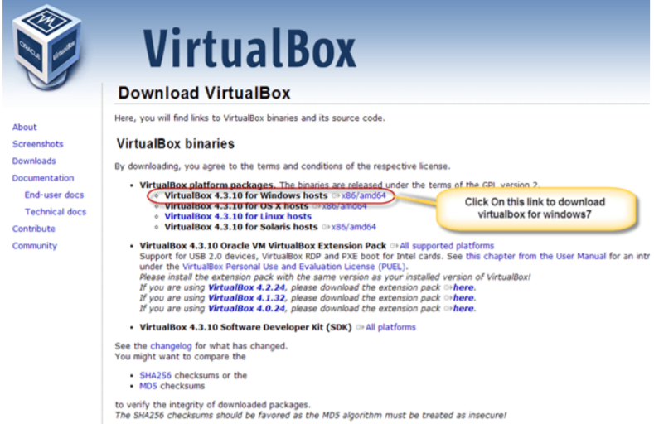

**Step-2:** When the download isdone,we need to Open setup file and follow the step and click **Next.**

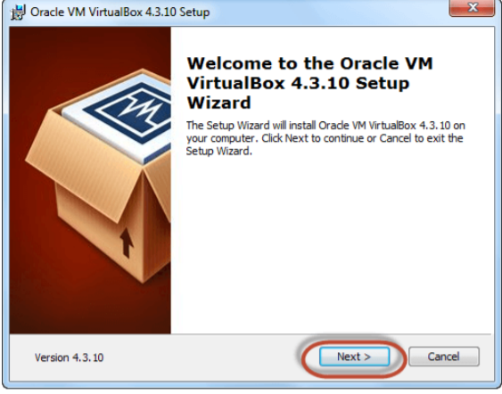

**Step-3:** After that Select the directory to install VirtualBox and click on **next.**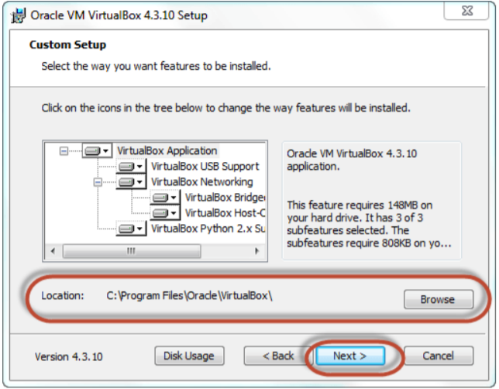

**Step-4:** Then we need to Select Desktop icon and click on next, thenclick on **yes**.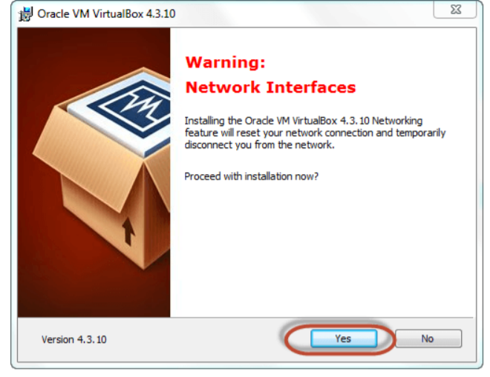

**Step-5:** Now Click On install.

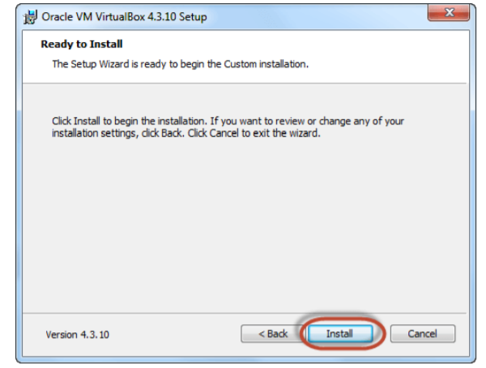

**Step-6:** Then installation of the virtual box will started. Once complete, click on Finish Button to start Virtual Box.

The virtual box dashboard looks like this

The virtual box dashboard looks like this

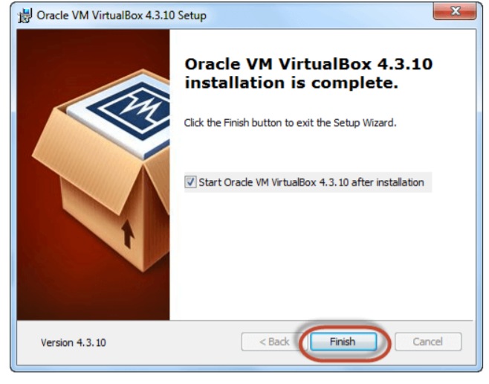

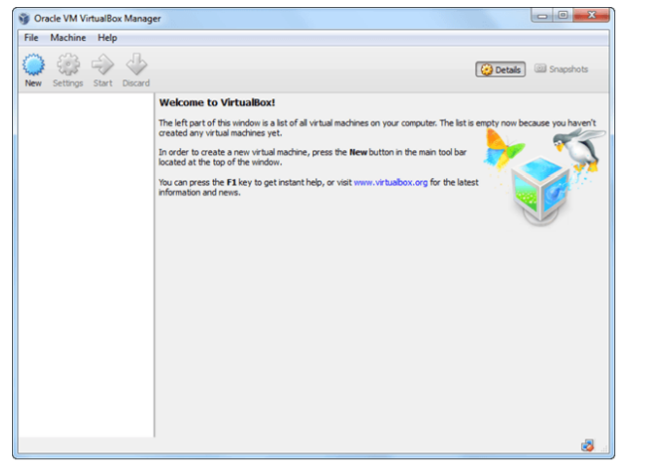

**Step-7:** Download Ubuntu.We can select 32/64-bit versions as per our choice.

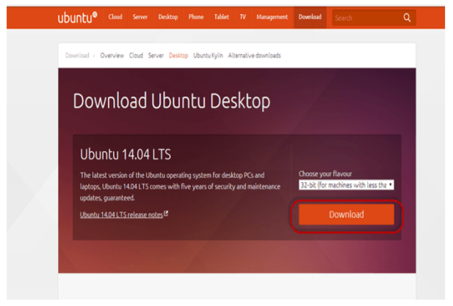

**Step-8:** Open Virtual box and click on new button

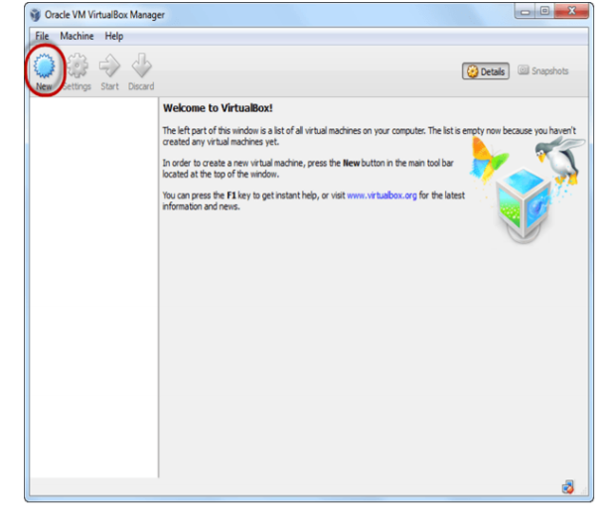

**Step-9:** In next window, we have to give the name of our OS which we are installing in virtual box. And select OS like Linux and version as Ubuntu 32 bit. And click on next

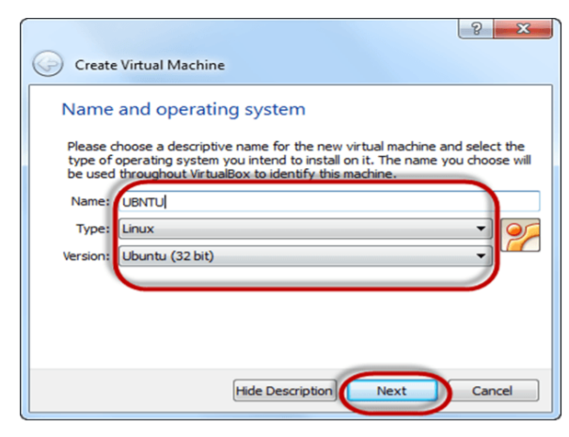

**Step-10:** Now have to allocate Ram Size To our Virtual OS. I recommended keeping 1024mb (1 GB) ram to run Ubuntu better. And click on next.

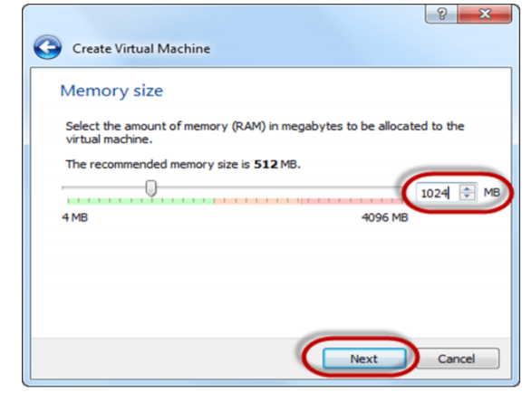

**Step-11**: Now To run OS in virtual box we have to create virtual hard disk, click on create a virtual hard drive now and click on create button. The virtual hard disk is where the OS installation files and data/applications we create/install in this Ubuntu machine will reside.

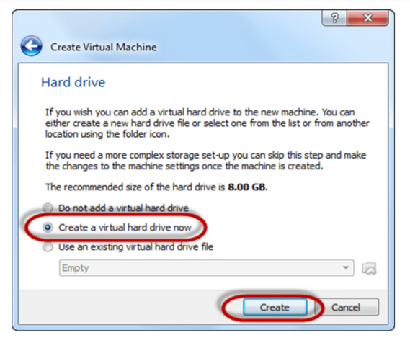

**Step-12:** select VHD (virtual hard disk) option and click on next.

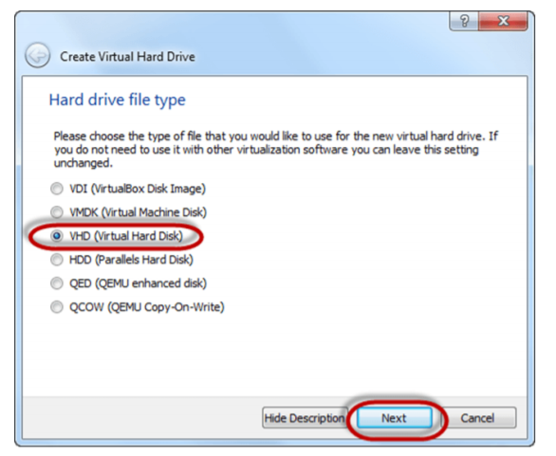

**Step-13:** Click on dynamic allocated and click on next. This means that the size of the disk will increase dynamically as per requirement.

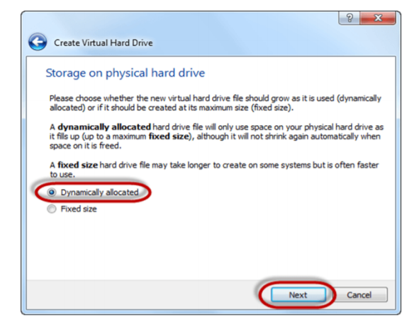

**Step-14:** Allocate memory virtual hard drive .8GB recommended. Click on create button.

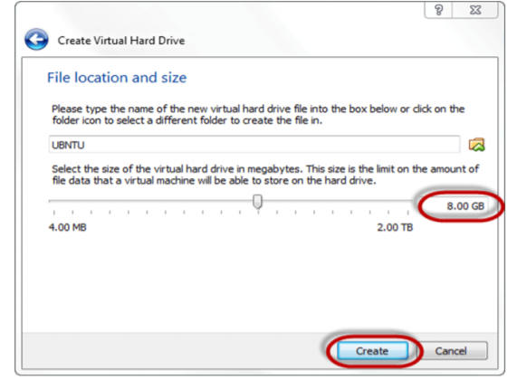

**Step-15:** Now we can see the machine name in left pane

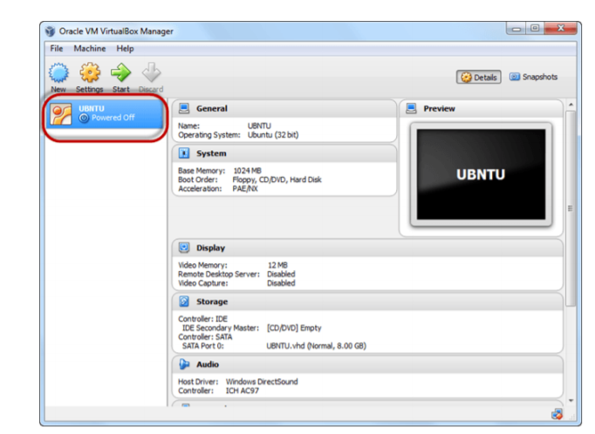

**Step-16:** Select the Machine and Click on Start

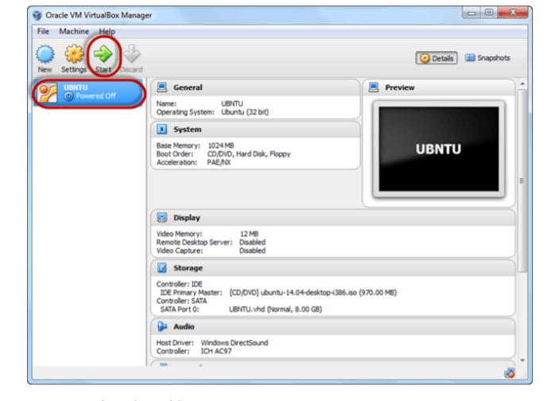

**Step-17:** Select the Folder Option

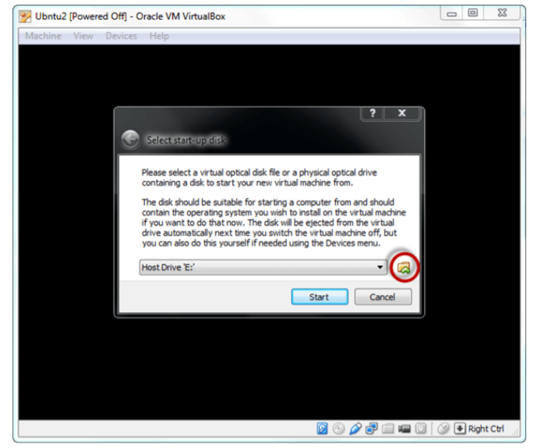

**Step-18:** Select the Ubuntu iso file

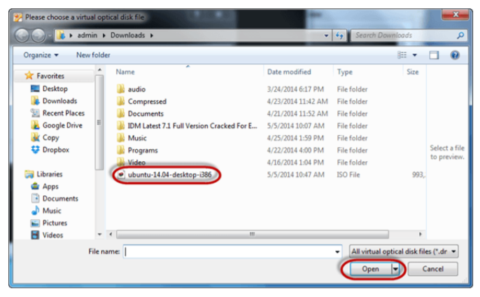

**Step-19:** Click Start

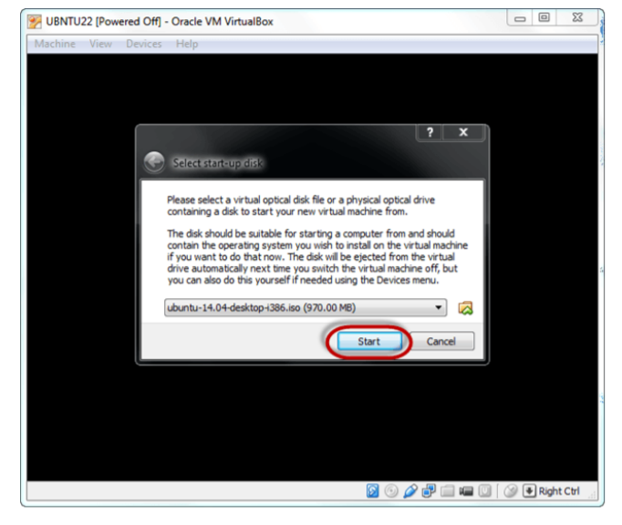

**Step-20:** We have an option to Run Ubuntu WITHOUT installing. We will install Ubuntu

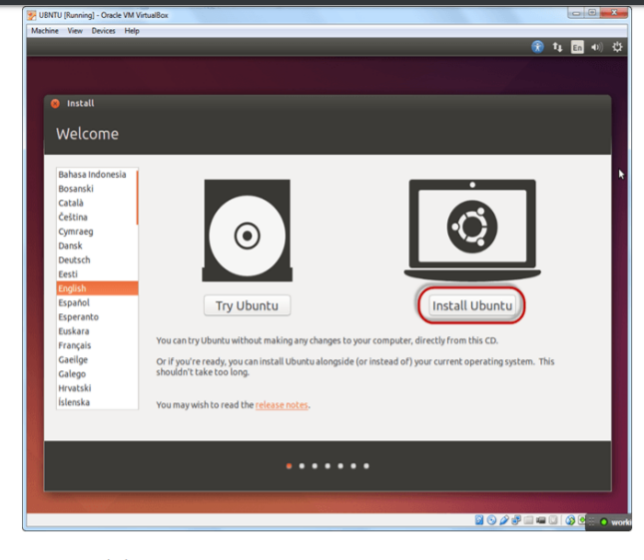

**Step-21:** Click continue

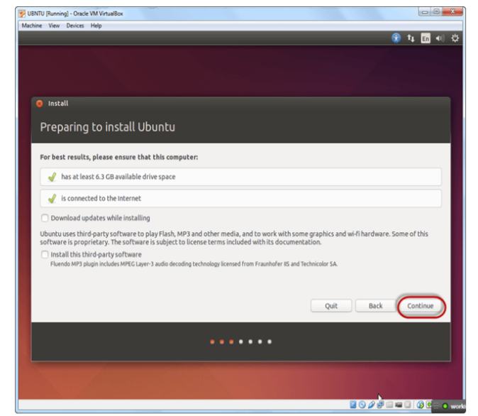

**Step-22:** Select option to erase the disk and install Ubuntu and click on install now. This option installs Ubuntu into our virtual hard drive which is we made earlier. It will not harm our PC or Windows installation

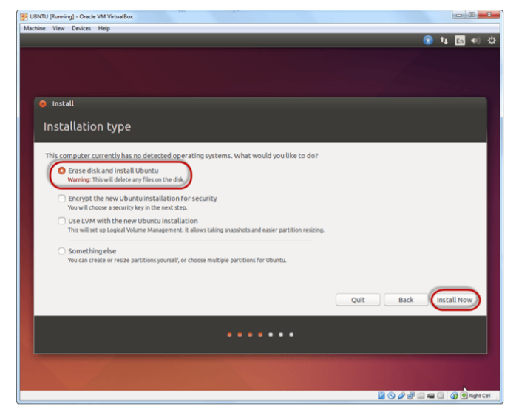

**Step-23:** Select location for setting up time zone, and click on continue

Step-24: Select keyboard layout, by default English (US) is selected but if we want to change then, we can select in the list. And click on continue

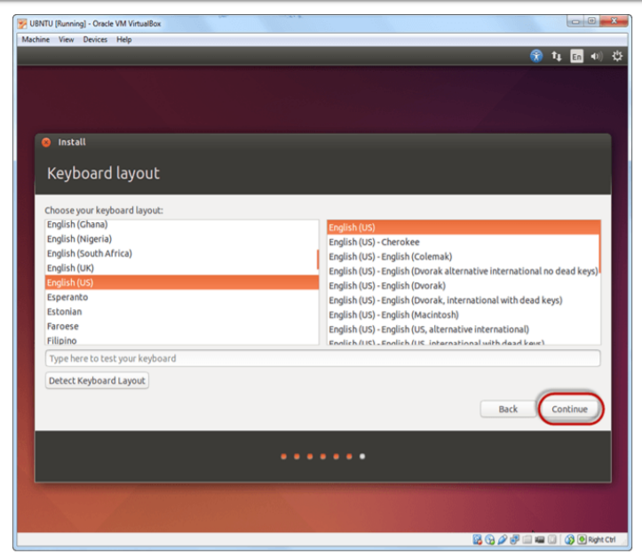

**Step-25:** Select username and password for Ubuntu admin account. This information has been needed for installing any software package into Ubuntu and also for login to OS. Fill up your details and tick on login automatically to ignore login attempt and click on continue

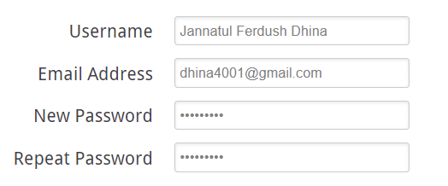

**Step-26:** Installation process starts. May take up to 30 minutes. Please wait until installation process completes

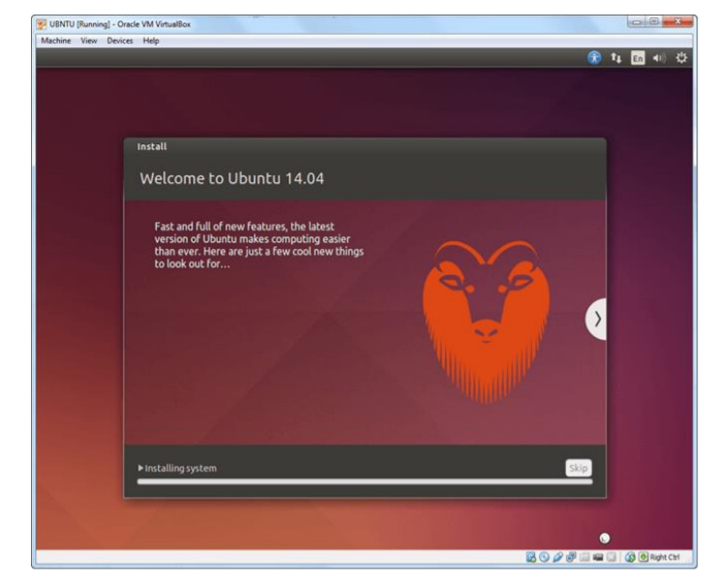

**Step-27:** After finishing the installation, we will see Ubuntu Desktop.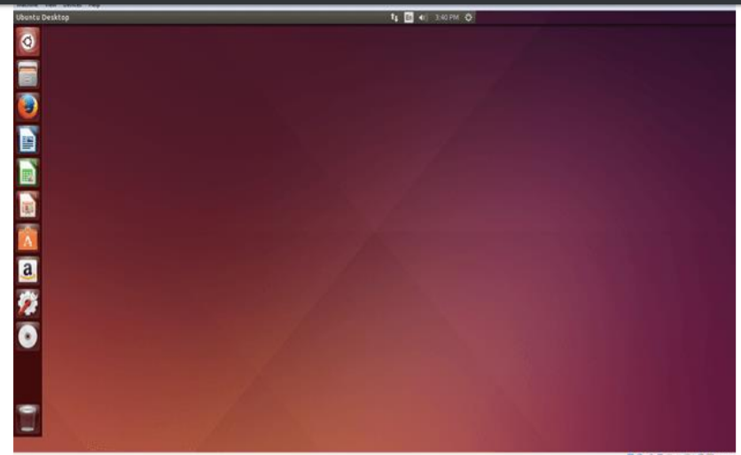

**Discussion:**

The Process of installing Linux was not so easy. I took a lot of help from friends. I think, now I can do it of my own.